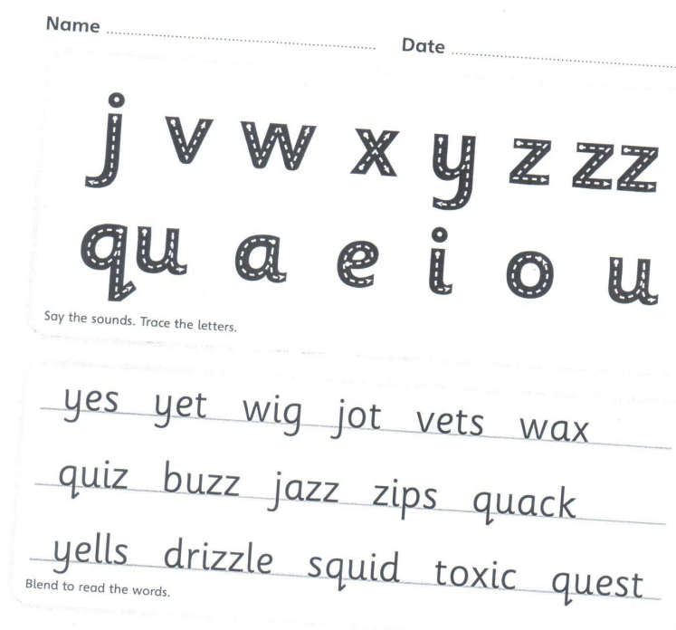

Copy the sentence out
The squid drizzles a toxic wax at a vet.
____________________________________________________________________
Now can you put quack into a sentence.
____________________________________________________________________

